Legislative Testimony Training

What is legislative testimony? Sometimes when legislative committees meet, they allow for public comment. Legislative testimony is just an opportunity for you to provide your opinion on a potential piece of legislation.

Why is it important? Every bill must be considered by and then passed out of a legislative committee before it can go up for vote in the House or Senate. This is your opportunity to share why you think the bill is a good one or a bad one.

Finding opportunities to testify:
By visiting http://calendar.legis.ga.gov/Calendar/?chamber=house and http://calendar.legis.ga.gov/Calendar/?Chamber=Senate during the legislative session, you can see what committee meetings are scheduled. Typically, the meeting notices will have a meeting agenda attached. This agenda tells you what bills are scheduled to be heard that day in committee.

It is very common for legislative committee meetings to have time changes, agenda changes, or even be canceled – all at the last minute. Try not to get frustrated, this is just a part of the legislative process here in Georgia.

Another way to stay in the loop is to reach out to an advocacy organization that is focused on the issue the bill discusses. If you have ever received an email alert from an organization about the bill, chances are that organization will be able to keep you up to date on the progress of that bill. Often advocacy organizations are actively looking for people to testify on a given issue and will appreciate you reaching out to them in advance to offer to testify when the time comes.

Writing legislative testimony:
Before starting to write, do remember that your purpose is not to be the expert on the bill or issue. Your only purpose is to share why you think this bill is good or bad. Do not get bogged down in researching every last bit of the issue. Your job is to be the expert on your life.

Always take the time to prepare your remarks. You may only have 3 minutes, which comes to about 500 words on paper. Type up your remarks. Practice reading them. Have a friend time you. It is better to say less at a slower pace than it is to talk fast and have the committee struggle to understand you.

As you get more comfortable with what you have written, try going a bit off script. Watching someone read a prepared script is not as engaging as someone who holds eye contact and only glances down occasionally. The more comfortable you are with your speech, the more natural it will come across.

A road map to writing legislative testimony:
- Greet everyone.
  - “Good afternoon Chairman ________ and members of the committee. Thank you for allowing me to speak with you today.
    - Good afternoon Chairman Werkheiser and members of the committee. Thank you for allowing me to speak with you today.
- Introduce yourself.
  - My name is _______ and I live in __________. I am a person with a disability/a family member with a disability.
    - My name is Sarah Jones and I live in Vidalia, GA. I am a person with a disability.
- Explain why you are speaking to them.
  - I am here today to speak with you about House Bill ____ which deals with _______. I want you to know that I support/do not support this bill.
    - I am here to speak with you about HB 831, which would create an Employment First Council here in Georgia. I want you to know that I support this bill.
- Share your thoughts on the bill.
  - This bill is important to me because ___________.
    - This bill is important to me because it is the first step in moving Georgia towards an Employment First state. For those of you that don’t know, Employment First is the idea that employment in an integrated setting and earning a competitive wage should be the first and preferred option for people with disabilities receiving publicly funded services, like the Medicaid waiver I rely on.
  - Address any misconceptions you know of. This is a great way to address the opposing side’s argument.
    - Some people say that Employment First will force people to work or that it will force people to leave their day programs. This is not true. Employment First simply means that employment should be the first option explored.
  - This would help me/my family by _____ OR This bill would hurt me/my family by _______. Be sure to make it personal.
    - We need this because too often people with disabilities such as myself are told we cannot work. This happened to me when I decided I wanted to go to work after high school. I wanted to earn real money working in the community but people kept pushing me away from the path to employment. I had to work hard to get the supports I needed to find and keep a job in the community. As of this year, I will have worked at my local diner for 6 years. Employment First simply means that when people like me are exploring how they wish to spend their days, they will first be encouraged to look at competitive integrated employment.
- Wrap everything up.
  - I hope you will keep me, and the many other Georgians with disabilities in mind when you vote on this bill.

- Thank them.
  - Thank you for listening to me. I would be happy to answer any questions you might have.
- Return to your seat.
  - If the committee doesn’t have any questions for you, they will likely thank you in return and you can return to your seat in the audience so that the next person can speak.
Signing Up: Every committee has their own system for signing up to testify. Once you know which committee you want to attend, look up who the Chairperson is of the committee. You can do that at house.ga.gov and senate.ga.gov under the Committee Tab. Call the Chairperson’s office and ask how people should sign up for public testimony.

They will likely tell you one of two things.
- They will take down your name and contact information to add you to the list of people testifying.
- There will be a sign-up sheet available in the committee room 10-20 minutes before the committee meetings starts.
Pro-Tips:
- Always arrive early. You never know what traffic, parking, or even the security line to enter the Capitol will be like. Some of the committee rooms are very small and fill up fast, this means you may have to arrive early to guarantee a seat or even a place to stand.
- Bring a small bottle of water with you when testifying.
- Never lie. Even if you feel there is a part of your story that may not put you in the best light. You do not have to share every part of your life with the legislators, but you should always be honest in what you do share.
- Try to remember that there is no test legislators must pass before they are elected or come to sit on a particular committee. Just because their committee deals with healthcare, doesn’t mean they are experts on the issue.
- Avoid using abbreviations or other pieces of jargon that most people will not know.
- Print extra copies of your statement to share with the committee members. Include your name, contact information, the date, and what committee you are appearing before. For your own copy, that you will use when testifying, make the font extra-large. This will make is easier to glance down.
- If you can, try to make eye contact with members of the committee while testifying.
- Do not argue with members of the committee or with people giving opposing testimony.
- Don’t be afraid to say “I don’t know, but I will get back to you,” if the committee asks you a question you don’t know the answer too.
- Send a thank you note to the committee members in attendance for allowing you to speak.

Content graciously borrowed from the Citizen Advocacy Center’s “Guidelines for Preparing, Writing, and Giving Testimony”http://www.citizenadvocacycenter.org/uploads/8/8/4/0/8840743/guidelines_for_preparing_writing_and_giving_testimony.pdf
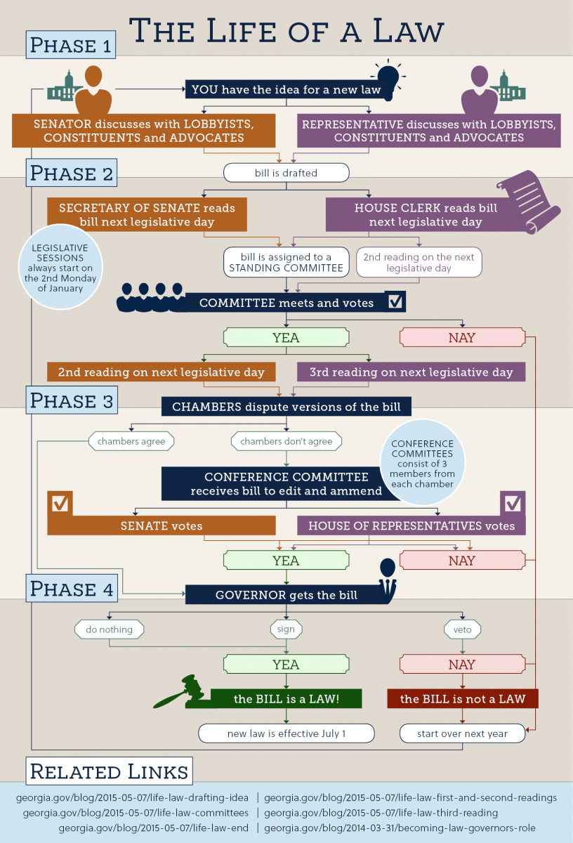
This is where legislative testimony fits into the process.

